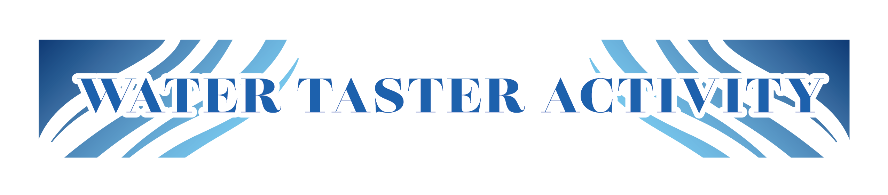

If you'd like to be a water-tasting judge, we invite friends to try this fun family activity!
SUPPLIES:
- Norland Pure Enhanced Premium water (bottled or from your dispenser).
- Tap water
- 1-2 bottles of another water brand (or as many as you'd like)
- Bonus – throw in flavored water for a "taste teaser."
- Clear cups
- Marker
- Paper

INSTRUCTIONS:
(Steps 1 & 2 should be done away from taste testers to ensure unbiased votes!)

- Number the clear cups with a marker to match the number of waters you are testing.
- Fill each cup with your different waters. Don’t forget to write a note to remind yourself which is which!
- Give your taste testers a piece of paper and writing utensils (or print this sheet).
Here's an example of the chart
 | Water #1 | Water #2 | Water #3 | Water #4 | Water #5
Appearance
Aroma
Taste
Mouth Feel
Aftertaste
Total

- Vote! Instruct your taste testers to try each water and score them from 1-5, with 5 being the best, based on each category. Read the pro tip next to each category for further instructions.
Appearance: *Water should be clear
Aroma: *Water should have no smell
Taste: *Water should taste clean
Mouth feel: *Water should feel light
Aftertaste: *Water should leave you thirsty for more
- Add the totals and reveal the brand name or type of water each taster liked best!

Norland Pure is excited to offer a printable Water Taster certificate on our website. Please share/tag your activity with Norland Pure to be featured on our social media pages.

